**Monitoring Application User Guide**

This guide explains how to use the key features of the Monitoring Application. Follow these steps to navigate through the application, create and manage monitors, and update details. Screenshots are included as visual pointers.

**1. Login**

**Step 1:**

* **Access the Login Page.**  
  Enter your username and password.

**Screenshot:**

* *Login Page* – (See image: **1_LoginPage.png**)

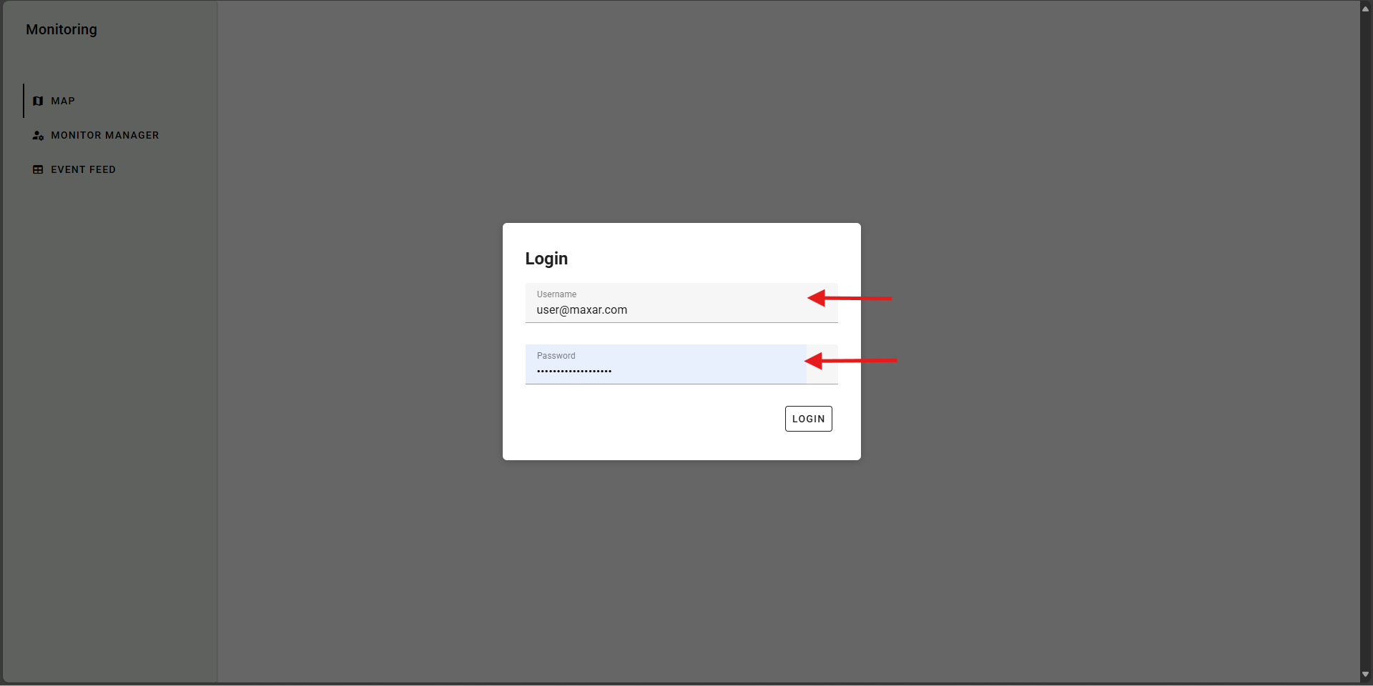

* + Notice the simple login form with fields for the username and password.

**Step 2:**

* **Click the “Login” button.**  
  Once your credentials are entered, click “Login” to proceed.

**2. Landing Page**

**Step 1:**

* **Overview of the Landing Page.**  
  After logging in, you’ll see an overview page of the map with the default location of Denver.

**Screenshot:**

* *Landing Page* – (See image: **Landing_Page.png**)

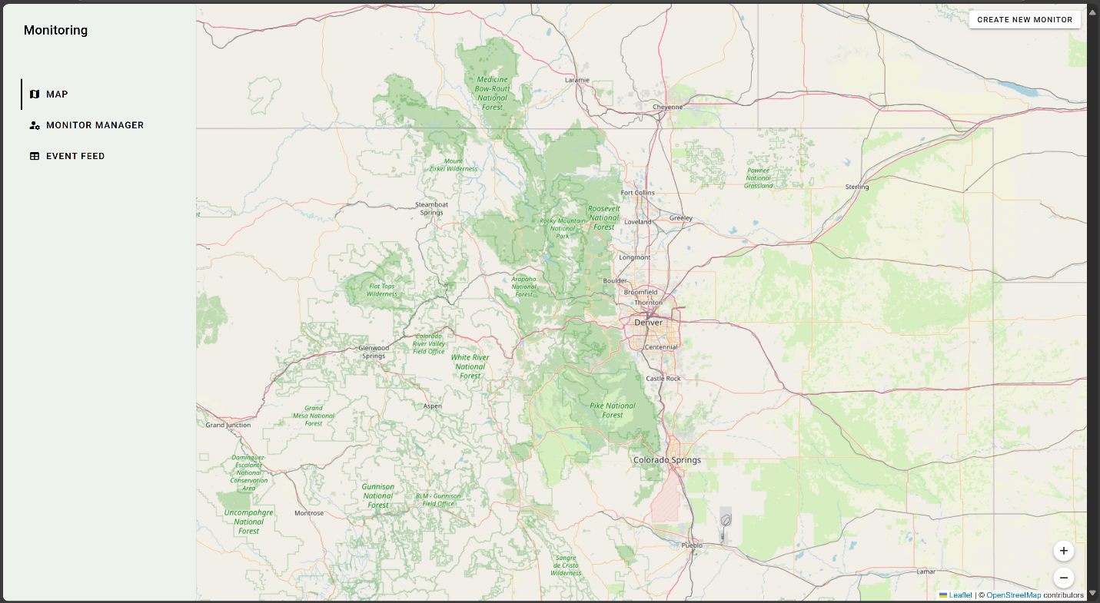

* + Take note of the navigation menu & the “Create New Monitor” button.

**3. Monitor Manager**

The Monitor Manager is the main hub for managing your monitors.

**Step 1:**

* **View the List of Monitors.**  
  The Monitor Manager page displays a table of monitors with the following columns:
  + Monitor ID
  + Store Name
  + Location (address)
  + Latest Update
  + Actions (to update or edit a monitor)

**Screenshot:**

* *Monitor Manager Page* – (See image: **Monitor_Manager_Page.png**)

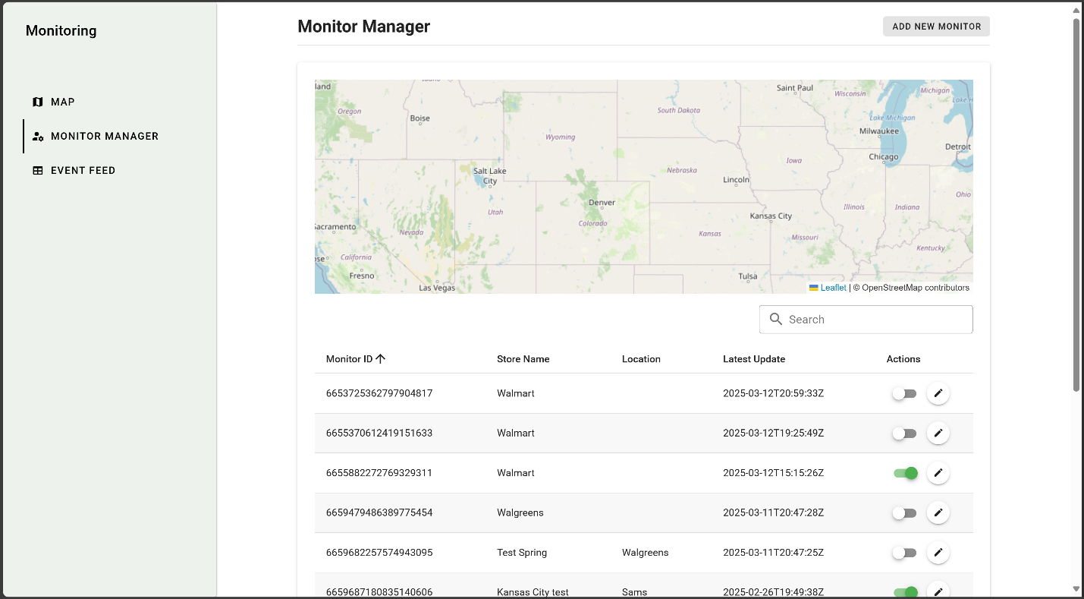

* + The table displays monitors with clear labels.

**Step 2:**

* **Search for Monitors.**  
  Use the search bar (with the magnifying glass icon) to filter monitors quickly.

**Step 3:**

* **Select a Monitor.**  
  Click on a table row to select a monitor.
  + The selected row will be highlighted.

**Screenshot:**

* *Row Selection* – (See image: **MM_Row_Selection.png**)
  + The screenshot highlights the selection effect on the table row. A “See Monitor Details” button is available if a monitor is selected.

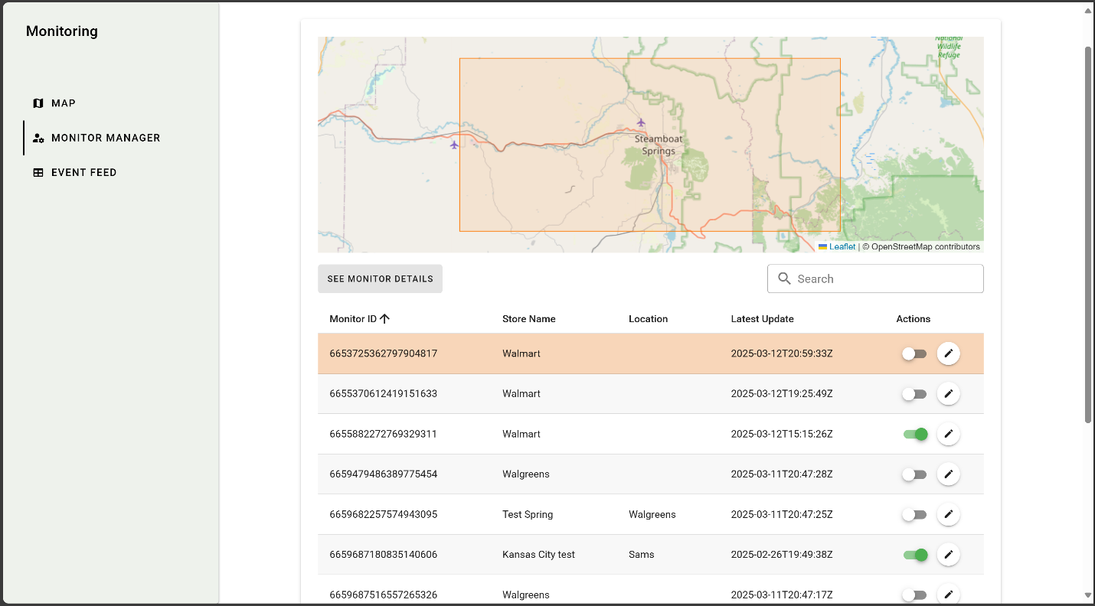

**4. Monitor Details**

Once you select a monitor, detailed information is displayed.

**Step 1:**

* **View Monitor Details.**  
  A separate Monitor Details view shows additional information, including the monitor’s specific settings and a map.

**Screenshot:**

* *Monitor Details* – (See image: **MM_Monitor_Details.png**)
  + The details screen displays the monitor’s identifier, associated store, and general overview.

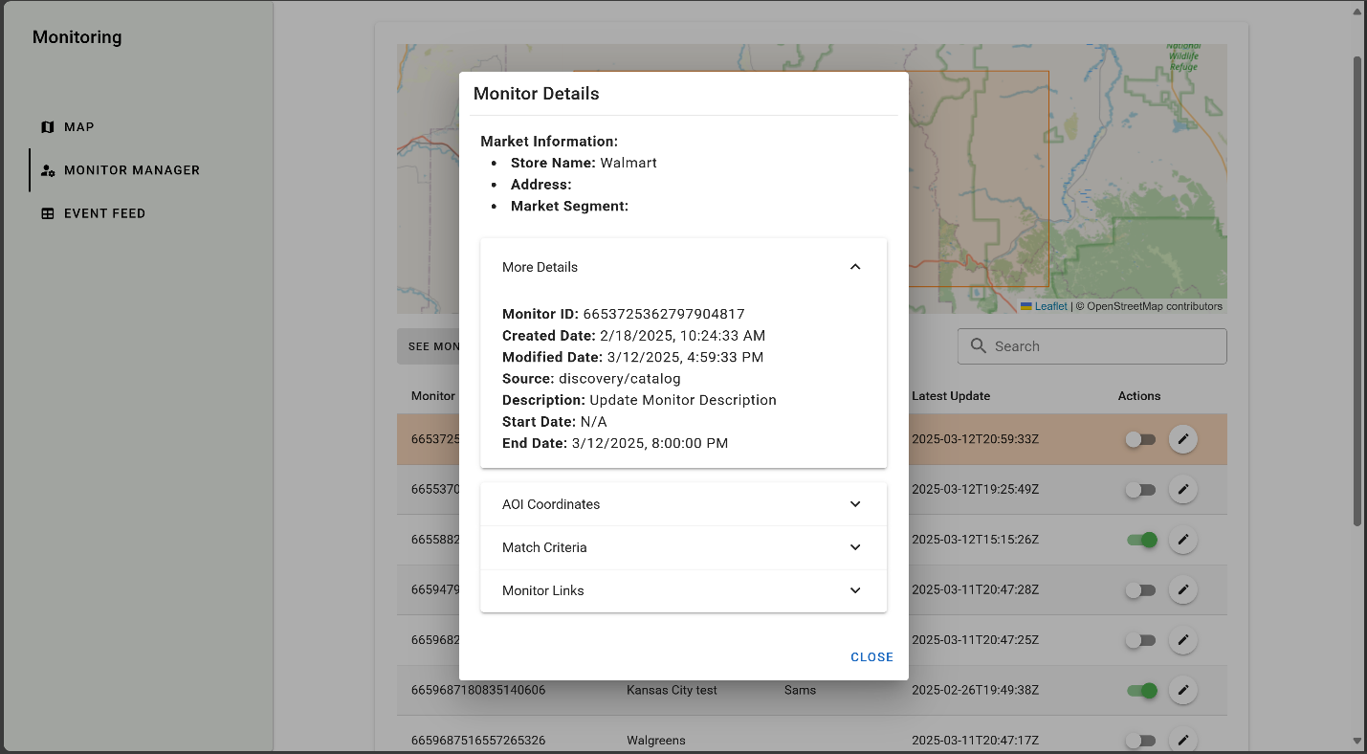

**Step 2:**

* **View the Area of Interest (AOI).**  
  A map displays the Area of Interest for the monitor, giving you a visual boundary of the location.

**Screenshot:**

* *Monitor Details – AOI* – (See image: **MM_Monitor_Details_AOI.png**)

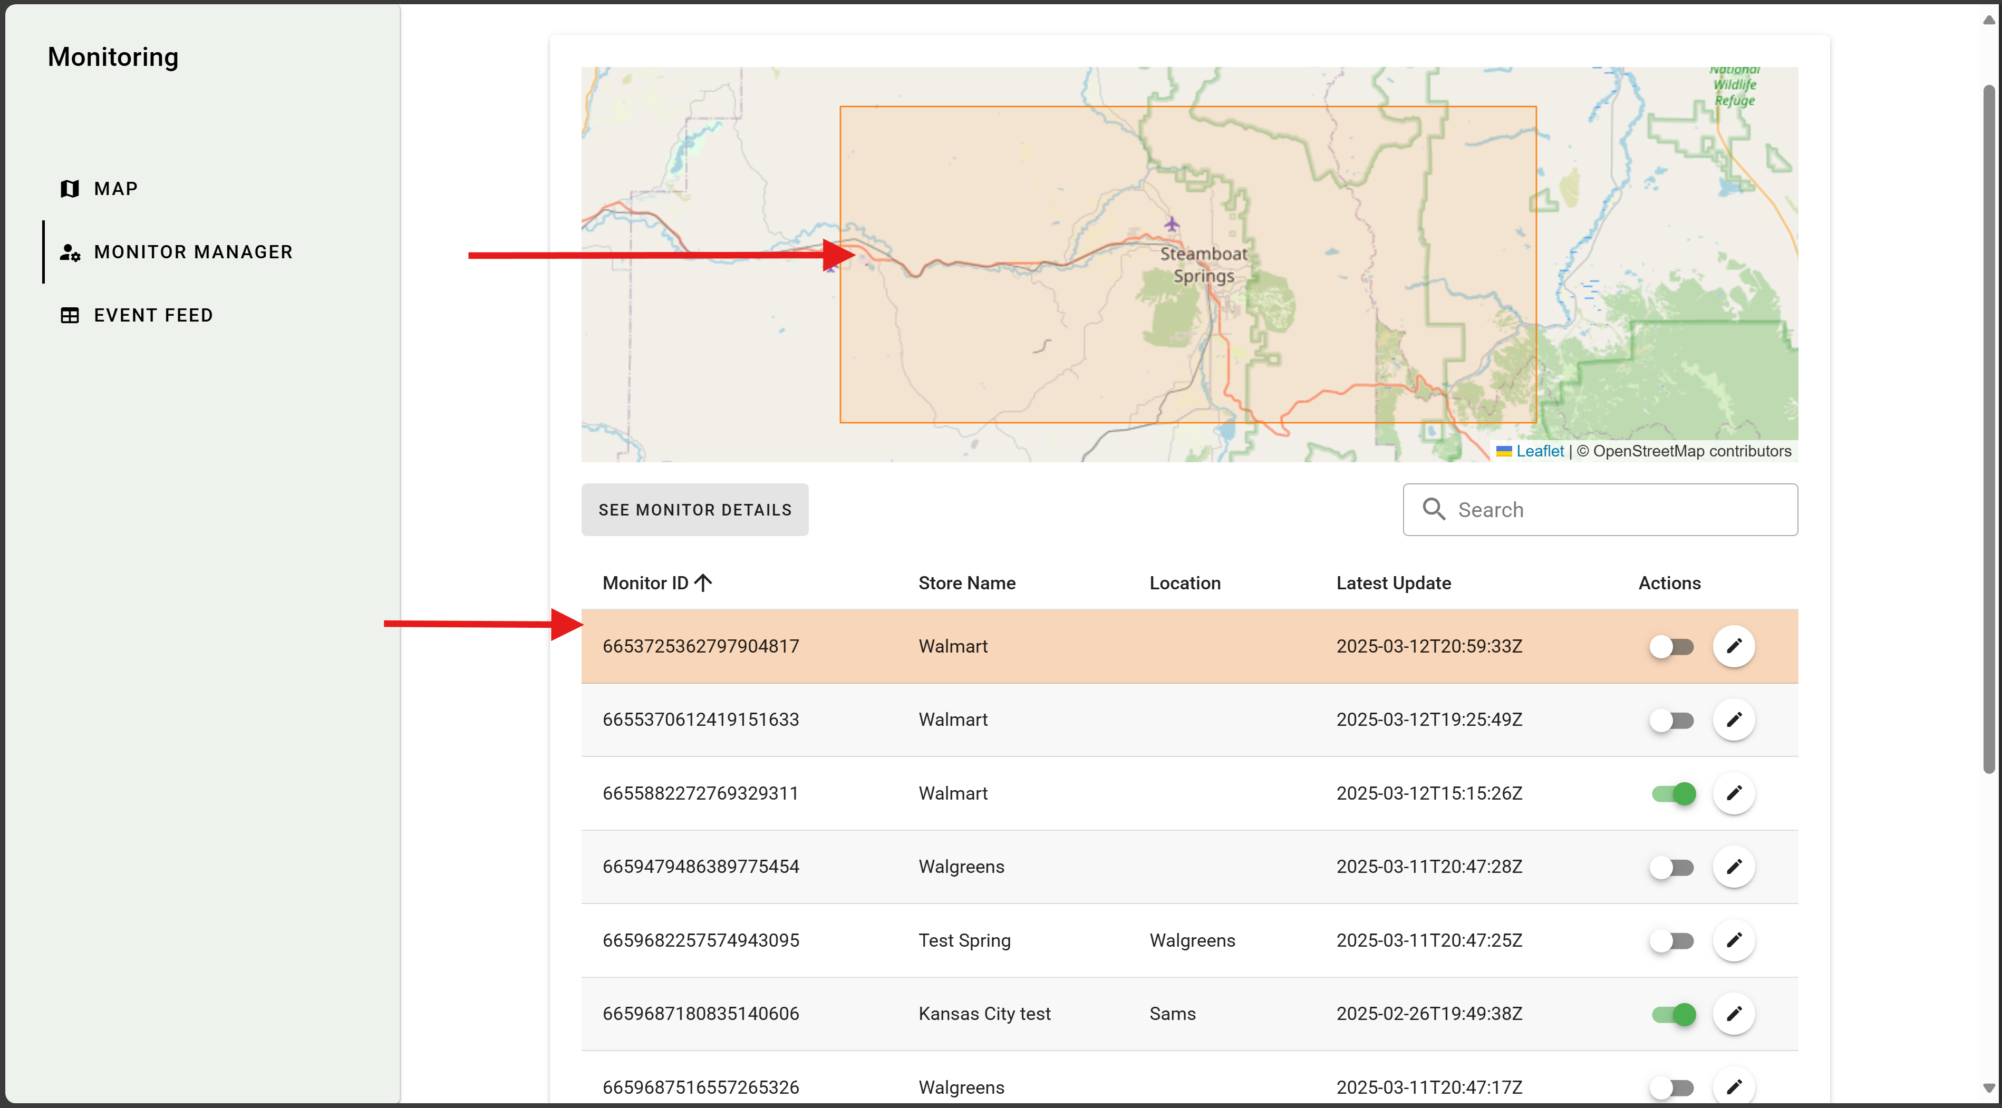

* + The map highlights the AOI with boundary markers.

**5. Update Monitor**

You can update a monitor’s details via the update modal.

**Step 1:**

* **Open the Update Monitor Modal.**  
  Click the edit (pencil) icon in the Actions column to bring up the update modal.

**Screenshot:**

* *Update Monitor* – (See image: **MM_Update_Monitor.png**)

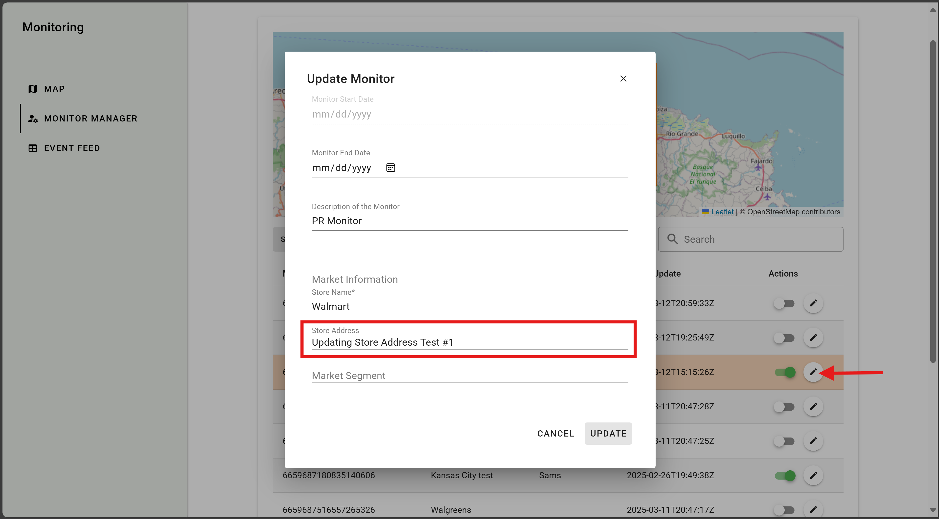

* + The modal allows you to edit the monitor’s details such as store information and the start and end date of the monitor.
  + Notice that some fields may be grayed out, that means the field can no longer be modified.

**Step 2:**

* **Make and Save Your Changes.**  
  Update the required fields and click “Save” to apply your changes.

**6. Event Feed**  
The **Event Feed** page shows real-time or historical events related to your monitors (e.g., state changes, new data arrivals).

**Step 1:**

* **Open the Event Feed Section.**  
  From the left menu, click **Event Feed** to see a chronological list of monitoring events.

**Screenshot:**

* *Event Feed*– (See image: **Event_Feed.png**)

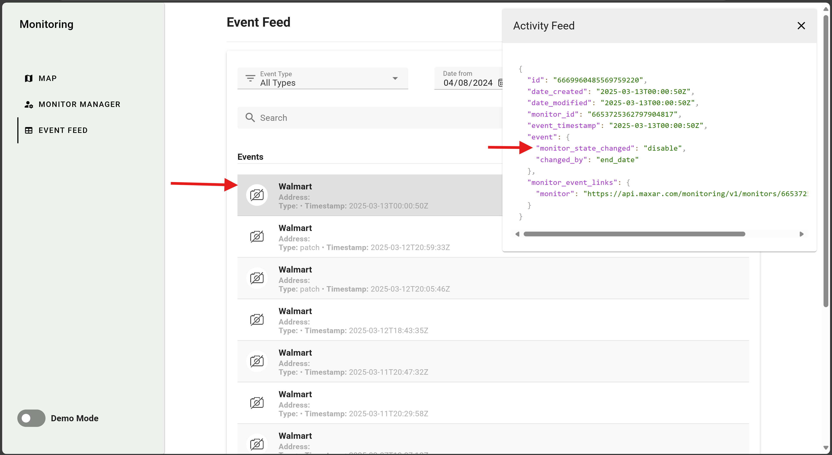

* 1. A **filter dropdown** at the top allows you to select the event type (e.g., All Types, Admin Events, etc.).
  2. The **events list** in the middle shows each event with details such as name and timestamp and if the event type is “Match” there will be a preview of the captured image where the “No Image” icon currently is.
  3. Clicking an event reveals a **details panel** on the right. It displays the event’s JSON payload, including keys like monitor_status_change, monitor_strp_changed, and more.

**Step 2:**

* **Use Filters.**  
  Adjust the **Event Type** filter to show specific categories of events.

**Step 3:**

* **View Event Details.**  
  Click on any event in the list to see its full metadata on the right panel. For example, you might see an event for "monitor_strp_changed": "disable" indicating a monitor’s state changed to “disabled.”

**Step 4:**

* **Scroll Through Past Events.**  
  Use the browser scrollbar or page navigation to view older events.

**Summary**

* **Logging In:** Enter your credentials on the Login Page.
* **Navigating:** Use the landing page, Monitor Manager and Event Feed to access key features.
* **Monitor Management:** Search, select, and review monitors in the table.
* **Monitor Details:** View detailed data and the AOI map for a selected monitor.
* **Updating Monitors:** Edit monitor details via the update modal.
* **Event Feed:** View all monitor events, search, filter & sort events. View detailed data for a selected event.

For additional help or troubleshooting, refer to the support documentation or contact your system administrator.